Planned Approach for Assignment 4

# Familiarize myself with the code.

The first step is to do a quick review of the objects, and the structure of the program, see what relates to what and where. I will produce a class diagram so I can visualize what is going on.

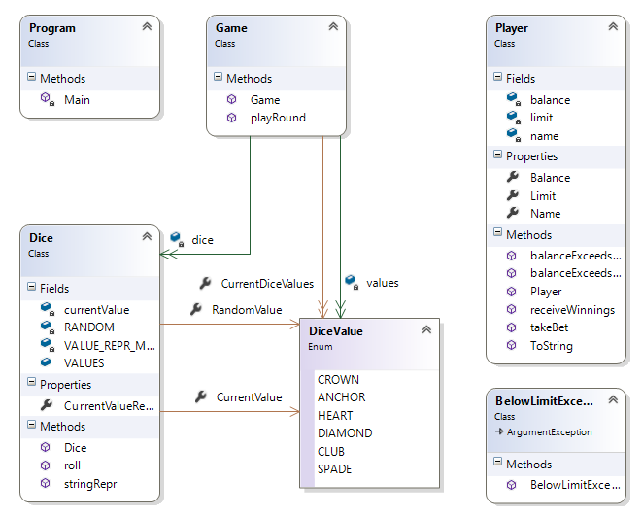

# Produce UAT Tests for each Bug

# Produce a broad Unit Test for each bug

# See if there are any obvious additional Tests that I can introduce to cover side-effects

# Introduce logging to console and file around the state of object in play

# Run look at where the Unit Tests fail and trace that line of code and check object states at those times

I may wrap tests around what the expected states should be.

# Manually step through the code, the stacktrace, and the object windows to see what is being set and where the bug is occurring

# Write a Unit Test to fix the bug

# Fix the Bug

# Test for Side-Effects